APPLICANT/CANDIDATE RESUME

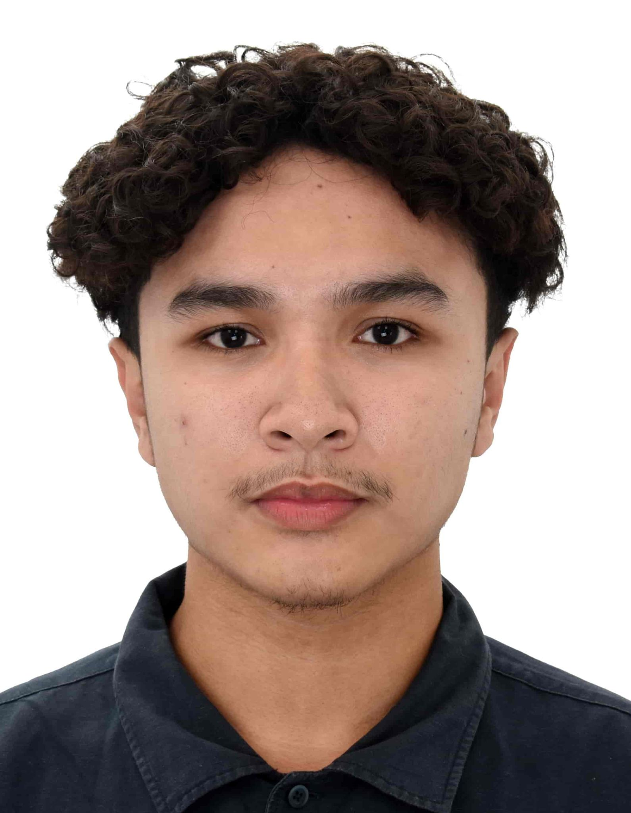
CONTACT INFORMATION

Matt Erron G. Cabarrubias
66A Buhisan Rd. Punta Princesa, Cebu City
+63 969 609 5336
business@mattliqht.dev
matt.cabarrubias@gmail.com

PERSONAL INFORMATION
Filipino
Male
Single
20 years old
Knows English, Cebuano and Tagalog

Computer PMS and Software skills
- Word Processing (Google Docs, Google Sheets, Word, Excel)
- Notion, Jira, Task Managers
- Web Development (Backend, Frontend, AI, DevOps)

EDUCATIONAL BACKGROUND (state year achieved)

1. Bachelor of Science in Computer Science
2024 - 2027
University of San Carlos - Talamban Campus

2. Senior High School - STEM
2022 - 2024
University of San Carlos - North Campus

3. High School
2018 - 2022
Don Bosco Technical College - Cebu

CERTIFICATIONS & ACCREDITATIONS

Fundamental Information Technology Engineers (FE) Certification Exam
PhilNITS FE4600116
April 2026

CCNA: Introduction to Networks
CISCO Networking
May 2025

STRENGTHS/TRAITS & SKILLS (see below examples)
- Strong presentation and communication skills
- Excellent time management when it comes to balancing work, school and my personal hobbies
- Dived into leadership roles in organizations
- Able to work within tight schedules

CAREER OBJECTIVES
Example: I wanna get rich and work on the big tech companies of the world: Google, Apple, Nvidia, xAI.

References

- Ritchie Diputado
Chief Technology Officer
EvoTech Software Solutions Inc. Cebu City Philippines
Contact Number

- Samuel Bonghanoy
Executive
Iridel Co. Cebu City Philippines
Contact Number

- Homer Adriel Dorin
Lead
Google Developer Groups on Campus - USC Cebu City Philippines Contact Number

Please add-on if you have more references

Resume updated on 26/07/2025

